**Introduction**

My research project is about if the amount of television that someone watches will affect their body image. To study this I surveyed 350 students asking them how much they weigh, how tall they are, how many hours of television they watch per week, and how they feel about their body. Psychologists have found that there is a direct correlation between the amount of media a person is exposed to and the way that they view their body. (In a negative or positive way)

**How is this Related to Biology?**

You might be wondering what body image and disordered thinking has to do with biology. Actually, it has a lot to do with it! In recent years, much research has indicated that there is genetic factors that contribute to disordered thinking. (Siegal 31) Children whose parents have suffered from an eating disorder are much more likely to have some sort of problem with body image or eating. Researchers believe that this is because people have genetic predisposition to disordered thinking. Also, People with eating disorders, are twice as likely to have variations in the gene for serotonin receptors, part of which helps determine the appetite. (Although not all people with poor body image have an eating disorder, all people with eating disorders have poor body image, and poor body image also helps lead to unhealthy eating habits or an eating disorder.) Often times those people have an overproduction of serotonin, which creates an overwhelming feeling of stress. Serotonin is a neurotransmitter, a group of chemical messengers that carry out communication in the brain and body. The messenger travels from one neuron to another, where they attach to a specific area called a receptor. This union, triggers signals that either allow or prevent a message from being passed on to other cells.(www.eating-disorders.net) Seretonin is a key element involved in hunger, sleep, depression and anxiety. High levels of seretonin cause such extreme anxiety that by not eating, a person feels a calming feeling, and a sense of control.

**Why was this topic chosen?**

This research topic was chosen because in the society that we live in today, people are constantly judging their self worth based on their appearance, and are being judged by the same criteria. I was curious if television actually does affect the way someone views their body. When turning on the television, at any hour of the day, at any channel, that question intrigued me more, as on every channel, there were extremely thin actors and actresses, people who do not look like the people I encounter in my daily life. Not only did I find the idea that the media could alter how we viewed ourselves, the thought that they had that power angered me. Our society places so much emphasis on superficial things like perfect figures that often times it can make people feel worthless because they are overweight, or do not fit into the cookie cutter mold cut out by society. Today, the average model weighs 23% below the national average. There are three billion women who don't look like supermodels, and only eight that do. Too often though, those realities are forgotten, and the images that Americans are constantly bombarded with become the measure of their self worth.

**Poor Body Image does not equal an Eating Disorder!**

Just because people have a poor body image does not mean that they have an eating disorder. But, Eating problems usually start out with the common wish to lose weight and maintain a certain body image. (Siege 7) That unhappiness with ones body often leads to disordered eating such as dieting, and sometimes develops into the extreme forms of unhealthy eating- Anorexia Nervosa or Bulimia Nervosa. Unfortunately, among teenagers the focus on body, dieting and weight is particularly acute. (Siegal 6)

**Males vs. Females**

My research project focused on the effect body image has on males versus females because typically 90% of people with disordered eating are females. It also focused on the ages of 12-18 because that is when typically disordered body images occur. (Siegal 13) Why is it that females are mostly affected, when television is watched by both male and females? "…It is more prevalent in females than in males because females are told that appearance is important while males are praised for other qualities…" (Claude-Pierre 69) The fact that females are more affected by the media angered me, as if the media is targeting females, trying to make them buy into the lies that they are not thin enough, so that they will come and buy the hoards of diet pills and programs available to all. As of 1990 the diet industry made $33 billion a year. How much of that is at the expense of the easily influenced adolescents. A commercial for Slim Fast said "It's a way of life- losing weight and feeling great- the Slim Fast way of life." (Kolodny 13) A life that always focuses on losing weight does not seem like a very healthy way of life.

**The Influence of the Media**

Think about the last television programming you watched. The overweight characters were typically portrayed as lazy, or socially outcast. The think characters are the successful, popular, sexy and powerful ones. What makes us think that we can tell our children that it's what is inside that counts when the media continuously contradicts this message. (www.eating-disorders.net) During the commercials, chances are that at least one diet ad was played, trying to convince you that if you lose weight, your life will be better, and you will be happier. The About-Face organization reported that "400-600 advertisements bombard us everyday in magazines, on billboards, on TV, and in newspapers. One in eleven of those has a direct message about beauty, not even counting the indirect messages.

The problem with all of these subtle influences, is that day after day, sooner or later their messages start to be believed, especially by adolescents and teenagers who are just trying to find themselves and get through their life. If someone is unhappy with their body image, their total self esteem will suffer, so someone will not give themselves credit for much, and in turn, their self perception will be affected. They might start to see themselves as heavy, when in reality, they have a very healthy body weight. (Kolodny, 16)

**What can we do to combat this problem?**

If all of this is true, maybe parents need to protect their children from the negative images that are allowed into their homes through the television, magazines and other forms of media. If those shows, articles etc are not supported and cease to stop making money, then slowly, these type of negative influences will stop showing up time and time again in our society. If my hypothesis is not rejected, parents must seriously think about the steps they can take to protect their children from this harmful thinking

**Hypothesis/Prediction**

Hypothesis: The amount of television that a female watches will affect their body image in a negative way and conversely the amount of television that a male watches will have no affect on their body image.

Prediction: If the amount of television a female watches affects their body image in a negative way, and the amount of television a male watches has no affect on their body image, then the females who watch a substantial amount of television will have poorer body image than those who watch very little.

**Biases**

**Types of Classes**-

The types of classes that were being surveyed could affect the responses. For example, usually someone in an Advanced Placement is a higher achiever then someone in a regular class, so they might view their bodies with harsher standards then someone else. For Freshman and Sophomore classes, I went to two P.E. classes, because all freshman and sophomores must take P.E. so there is a even distribution of all different kids. For the Junior and Senior classes, it was more difficult because there is a selection of classes available to them. To try and survey a variety of kids I surveyed 10 from 5 different classes in each grade, 5 male and 5 female in each class. This would ensure a variety of people were questioned. The children in middle school were much easier to survey because they were all in regular required classes that were randomly distributed with students.

**There is a variety of television shows-**

Obviously, with the technology offered today, there is a huge variety of programs offered on television. At any given time sitcoms, dramas, soap operas, documentaries, learning programs, made for T.V movies and even talk shows can be viewed. The only constant in all television programs is commercials- small pieces that use models and celebrities to help sell their product. These commercials have the ability to influence what people want to buy, so it seems like they would also have the ability to influence how people want to look. Also, most adolescents and teens watch the same type of programming, or at the very least watch programming during the same times of the day, when they are not at school, so if people were not watching similar shows, the large testing pool would help eliminate viewers watching shows without images of thin bodies or people influencing the way they feel about their own bodies.

**Television is not the only thing that could influence the way someone feels about their bodies-**

Television is only one type of media, and movies, magazines, the environment one grows up in and even genetic disposition can determine ones body image. For that reason I choose a testing size of three hundred, because the majority would watch television and be influenced by it. I chose television is the variable because television does not only feature shows but also movies, models that are also featured in magazines and commercials. in that way, television had the most components that could influence one's body image than any other type of media. It is also the easiest to know the number of hours you watch television a week rather then say the number of pages you read from a magazine a week.

**Lying about their weight… or just not knowing-**

Some students may feel embarrassed about their weight, so I instructed all of them to not put their names on the sheets and to fold them in half when they turn them in so that they would be confidential and no one would know their answers. Some students also might not know what their weight is so they might just be guessing. Again, this is where the large sample size was important so a few guesses would not influence the data.

**Survey-Procedure**

**Materials:**

For this project, materials were minimal. All that was needed were 350 surveys, 350 students (50 from each grade, grades 6-12, 25 males and 25 females).

I put words such as overweight average and underweight on the survey instead of words like fat and skinny because those words hold too much emotion and are more difficult to define.

**The Survey:**

The survey that was given out looked like this.

What grade are you in: _____ Age:___

Please circle one: M or F

Height:______ Weight:____

Circle one- When you look in the mirror, do you feel: Underweight?

Average?

Overweight?

How many hours of television do you watch a week? ______

Thank you for taking the time to fill out this survey!

**Procedure:**

1) Ask teachers from each class that you want to survey a few days ahead if it would be ok for you to survey their class.

2) Distribute Questionnaires

* At the middle schools:

Distribute the questionnaires, 50 to a grade, 25 of which are male and 25 female at a P.E. class for all grades.

* Freshman and Sophomores:

Distribute the questionnaires, 50 to a grade, 25 of which are male and 25 female at a P.E. class.

* Juniors and Seniors:

Distribute the questionnaires to five different regular subject classes of each grade, 10 in each subject, 5 of those male, the other 5 female. Repeat for the next grade.

3) Ask each student to please fill it out honestly. Explain that their answers are confidential and that it is for a science project so it is important for the answers to be truthful.

4) Instruct each student to fold their surveys and return to me.

5) Thank them for filling out the surveys and start consolidating the data!

**Data**

**6th Grade Females**

|  |  |  |  |
| --- | --- | --- | --- |
| Height | Weight | Hours of TV | Body Image |
| 4'10 | 90 | 2 | Average |
| 4'10 | 82 | 1.5 | Average |
| 5'2 | 100 | 2 | Average |
| 4'11 | 86 | 5 | Average |
| 4'11 | 93 | 6 | Overweight |
| 5'0 | 92 | 0 | Average |
| 5'0 | 75 | 6 | Average |
| 4'9 | 70 | 3 | Average |
| 4'11 | 88 | 5.5 | Overweight |
| 5'3 | 108 | 5 | Overweight |
| 5'2 | 100 | 6 | Overweight |
| 5'1 | 89 | 14 | Average |
| 5'4 | 110 | 20 | Average |
| 4'10 | 83 | 7 | Overweight |
| 4'1 | 68 | 5 | Underweight |
| 5'1 | 85 | 9 | Overweight |
| 4'11 | 90 | 7.5 | Overweight |
| 5'1 | 85 | 6 | Average |
| 4'6 | 71 | 11 | Average |
| 4'11 | 89 | 16 | Overweight |
| 5'1 | 80 | 5 | Average |
| 5'2 | 101 | 4 | Overweight |
| 5'1 | 99 | 10 | Overweight |
| 4'9 | 95 | 2 | Average |
| 5'0 | 92 | 7 | Overweight |

**6th Grade Males**

|  |  |  |  |
| --- | --- | --- | --- |
| Height | Weight | Hours of TV | Body Image |
| 5'0 | 80 | 7 | Underweight |
| 5'1 | 95 | 1.5 | Average |
| 5'0 | 138 | 4 | Average |
| 4'11 | 80 | 7 | Overweight |
| 4'11 | 70 | 12 | Average |
| 5'0 | 88 | 6 | Average |
| 4'11 | 79 | 8 | Underweight |
| 5'0 | 98 | 8 | Average |
| 5'0 | 120 | 7 | Average |
| 5'1 | 80 | 2.5 | Average |
| 5'3 | 103 | 10 | Average |
| 5'0 | 100 | 6.5 | Average |
| 4'9 | 86 | 4 | Underweight |
| 5'1 | 93 | 3 | Average |
| 5'0 | 101 | 6 | Average |
| 4'6 | 70 | 5 | Average |
| 4'11 | 80 | 7 | Average |
| 4'9 | 89 | 19 | Overweight |
| 5'1 | 95 | 1 | Average |
| 5'3 | 125 | 6 | Average |
| 5'0 | 80 | .5 | Average |
| 5'3 | 92 | 2 | Average |
| 4'6 | 60 | 10 | Underweight |
| 4'10 | 95 | 8 | Average |
| 4'11 | 75 | 2 | Average |

**7th Grade Females**

|  |  |  |  |
| --- | --- | --- | --- |
| Height | Weight | Hours of TV | Body Image |
| 5'8 | 100 | 16 | Underweight |
| 5'2 | 100 | 5 | Overweight |
| 5'3 | 114 | 24 | Average |
| 5'4 | 122 | 21 | Average |
| 5'2 | 103 | 4 | Overweight |
| 5'0 | 86 | 5 | Average |
| 5'2 | 98 | 10 | Overweight |
| 5'6 | 115 | 13 | Overweight |
| 5'2 | 93 | 5 | Average |
| 5'7 | 135 | 2 | Average |
| 5'4 | 113 | 9 | Overweight |
| 5'3 | 115 | 12 | Overweight |
| 5'1 | 110 | 11 | Overweight |
| 4'11 | 97 | 8 | Overweight |
| 5'2 | 85 | 5 | Average |
| 5'5 | 115 | 7 | Underweight |
| 5'2 | 95 | 5 | Average |
| 5'1 | 100 | 10 | Overweight |
| 5'0 | 88 | 7 | Average |
| 5'2 | 98 | 12 | Overweight |
| 4'11 | 81 | 15 | Average |
| 5'2 | 89 | 11 | Overweight |
| 5'7 | 120 | 10 | Overweight |
| 5'2 | 85 | 25 | Average |
| 5'6 | 135 | 9 | Overweight |

**7th Grade Males**

|  |  |  |  |
| --- | --- | --- | --- |
| Height | Weight | Hours of TV | Body Image |
| 5'2 | 85 | 5 | Underweight |
| 5'4 | 140 | 25 | Overweight |
| 4'11 | 75 | 12 | Underweight |
| 5'2 | 100 | 9 | Underweight |
| 5'7 | 125 | 6 | Overweight |
| 5'1 | 96 | 7 | Underweight |
| 5'3 | 101 | 6 | Underweight |
| 5'6 | 122 | 15 | Underweight |
| 4'10 | 82 | 20 | Underweight |
| 5'0 | 100 | 10 | Average |
| 5'8 | 140 | 12 | Overweight |
| 5'4 | 111 | 14 | Average |
| 5'6 | 130 | 5 | Average |
| 5'5 | 115 | 10 | Underweight |
| 5'3 | 110 | 12 | Underweight |
| 5'7 | 125 | 6 | Overweight |
| 5'5 | 140 | 15 | Overweight |
| 5'2 | 110 | 5 | Average |
| 5'0 | 100 | 6 | Average |
| 5'2 | 117 | 10 | Overweight |
| 5'1 | 97 | 12 | Underweight |
| 5'4 | 111 | 16 | Underweight |
| 5'2 | 108 | 3 | Average |
| 5'4 | 120 | 9 | Average |
| 5'7 | 145 | 12 | Overweight |

**8th Grade Females**

|  |  |  |  |
| --- | --- | --- | --- |
| Height | Weight | Hours of TV | Body Image |
| 5'7' | 120 | 12 | Average |
| 5'5 | 150 | 14 | Average |
| 5'1 | 94 | 8 | Overweight |
| 5'2 | 101 | 10 | Overweight |
| 5'4 | 106 | 11 | Overweight |
| 5'2 | 120 | 7 | Overweight |
| 5'3 | 135 | 12 | Overweight |
| 5'7 | 125 | 2 | Average |
| 5'0 | 88 | 6 | Overweight |
| 5'3 | 133 | 11 | Overweight |
| 5'4 | 104 | 4 | Average |
| 5'5 | 113 | 3 | Overweight |
| 5'3 | 101 | 7 | Average |
| 5'2 | 87 | 5 | Average |
| 5'5 | 130 | 2 | Overweight |
| 5'4 | 121 | 15 | Overweight |
| 5'3 | 120 | 20 | Average |
| 5'6 | 130 | 10 | Overweight |
| 5'2 | 100 | 16 | Overweight |
| 5'0 | 98 | 3 | Average |
| 5'3 | 127 | 20 | Average |
| 5'6 | 120 | 20 | Average |
| 5'4 | 110 | 7 | Overweight |
| 5'0 | 75 | 2 | Underweight |
| 5'6 | 109 | 8 | Average |

**8th Grade Males**

|  |  |  |  |
| --- | --- | --- | --- |
| Height | Weight | Hours of TV | Body Image |
| 5'6 | 175 | 10 | Overweight |
| 5'1 | 126 | 15 | Overweight |
| 5'3 | 105 | 16 | Average |
| 5'1 | 80 | 7 | Average |
| 5'9 | 115 | 8 | Average |
| 5'6 | 113 | 9 | Average |
| 5'2 | 115 | 11 | Average |
| 5'5 | 136 | 10 | Average |
| 5'9 | 150 | 15 | Average |
| 5'5 | 150 | 10 | Overweight |
| 5'3 | 111 | 15 | Underweight |
| 5'9 | 115 | 8 | Average |
| 5'7 | 125 | 2 | Average |
| 4'9 | 90 | 6 | Underweight |
| 5'6 | 132 | 25 | Average |
| 5'0 | 100 | 3 | Average |
| 5'4 | 130 | 6 | Overweight |
| 5'5 | 145 | 8 | Average |
| 4'11 | 89 | 7 | Underweight |
| 5'9 | 102 | 2 | Average |
| 5'8 | 160 | 7 | Overweight |
| 5'3 | 107 | 9 | Average |
| 5'6 | 164 | 11 | Overweight |
| 5'5 | 115 | 5 | Average |
| 5'5 | 120 | 12 | Average |

**9th Grade Females**

|  |  |  |  |
| --- | --- | --- | --- |
| Height | Weight | Hours of TV | Body Image |
| 5'3 | 145 | 15 | Overweight |
| 5'7 | 125 | 10 | Overweight |
| 5'7 | 145 | 10 | Overweight |
| 5'5 | 135 | 4 | Overweight |
| 5'5 | 115 | 10 | Average |
| 5'2 | 110 | 4 | Overweight |
| 5'3 | 120 | 16 | Overweight |
| 5'3 | 112 | 4 | Average |
| 5'3 | 117 | 2 | Overweight |
| 5'5 | 106 | 14 | Average |
| 5'3 | 117 | 9 | Average |
| 5'3 | 107 | 7 | Average |
| 5'6 | 130 | 3 | Overweight |
| 5'6 | 110 | 10 | Overweight |
| 5'2 | 110 | 11 | Overweight |
| 5'1 | 95 | 15 | Overweight |
| 5'7 | 115 | 13 | Average |
| 5'4 | 110 | 10 | Overweight |
| 5'2 | 111 | 3 | Average |
| 4'11 | 86 | 4 | Average |
| 5'0 | 99 | 8 | Overweight |
| 5'9 | 125 | 6 | Average |
| 5'3 | 115 | 8 | Average |
| 5'2 | 100 | 2 | Average |
| 5'4 | 116 | 9 | Overweight |

**9th Grade Males**

|  |  |  |  |
| --- | --- | --- | --- |
| Height | Weight | Hours of TV | Body Image |
| 5'4 | 125 | 6 | Average |
| 5'6 | 140 | 14 | Average |
| 6'3 | 185 | 5 | Average |
| 5'8 | 170 | 0 | Overweight |
| 5'8 | 145 | 15 | Average |
| 5'7 | 173 | 20 | Average |
| 5'6 | 125 | 14 | Average |
| 6'2 | 162 | 10 | Average |
| 5'7 | 142 | 3 | Average |
| 5'8 | 165 | 5 | Overweight |
| 5'6 | 115 | 10 | Underweight |
| 5'8 | 120 | 2 | Underweight |
| 6'2 | 215 | 21 | Overweight |
| 5'10 | 150 | 5 | Average |
| 5'6 | 125 | 15.5 | Average |
| 5'9 | 135 | 20 | Average |
| 5'10 | 145 | 20 | Overweight |
| 5'7 | 140 | 10 | Average |
| 5'9 | 157 | 3 | Average |
| 5'4 | 110 | 12 | Underweight |
| 5'4 | 120 | 15 | Average |
| 5'2 | 113 | 16 | Average |
| 5'8 | 146 | 5 | Average |
| 5'9 | 155 | 8 | Average |
| 5'3 | 115 | 8.5 | Average |

**10th Grade Females**

|  |  |  |  |
| --- | --- | --- | --- |
| Height | Weight | Hours of TV | Body Image |
| 5'5 | 125 | 4 | Average |
| 5'7 | 170 | 8 | Overweight |
| 5'7 | 130 | 12 | Overweight |
| 5'5 | 116 | 10 | Average |
| 5'8 | 145 | 10 | Average |
| 5'4 | 130 | 3.5 | Average |
| 5'4 | 120 | 4 | Overweight |
| 5'6 | 170 | 7 | Overweight |
| 5'1 | 104 | 4 | Average |
| 5'4 | 135 | 4 | Average |
| 5'5 | 120 | 2 | Average |
| 5'6 | 130 | 8 | Overweight |
| 5'9 | 121 | 7 | Average |
| 5'6 | 116 | 9 | Overweight |
| 5'4 | 114 | 5 | Overweight |
| 5'6 | 126 | 9 | Overweight |
| 5'7 | 130 | 16 | Overweight |
| 5'9 | 132 | 19 | Overweight |
| 5'2 | 110 | 4 | Average |
| 5'6 | 118 | 21 | Overweight |
| 5'3 | 100 | 4 | Average |
| 5'5 | 118 | 2 | Average |
| 5'5 | 130 | 2 | Average |
| 5'4 | 115 | 8 | Overweight |
| 5'8 | 140 | 10 | Overweight |

**10th Grade Males**

|  |  |  |  |
| --- | --- | --- | --- |
| Height | Weight | Hours of TV | Body Image |
| 5'6 | 160 | 24 | Overweight |
| 5'6 | 148 | 25 | Average |
| 5'6 | 125 | 8 | Underweight |
| 5'11 | 140 | 7 | Average |
| 5'4 | 120 | 5 | Average |
| 5'10 | 160 | 5 | Average |
| 5'5 | 130 | 3 | Average |
| 5'7 | 143 | 5 | Average |
| 5'6 | 125 | 6 | Underweight |
| 5'8 | 140 | 10 | Average |
| 5'9 | 155 | 10 | Average |
| 5'9 | 160 | 10 | Average |
| 5'8 | 165 | 2 | Average |
| 6'3 | 200 | 10 | Average |
| 5'10 | 150 | 10 | Average |
| 5'6 | 134 | 8 | Average |
| 5'2 | 110 | 4 | Average |
| 5'4 | 135 | 8 | Average |
| 5'8 | 167 | 10 | Overweight |
| 5'4 | 152 | 7 | Overweight |
| 5'2 | 108 | 11 | Underweight |
| 5'6 | 140 | 20 | Average |
| 5'10 | 170 | 7 | Average |
| 6'3 | 180 | 10 | Average |
| 5'3 | 115 | 9 | Underweight |

**11th Grade Females**

|  |  |  |  |
| --- | --- | --- | --- |
| Height | Weight | Hours of TV | Body Image |
| 5'3 | 145 | 2 | Overweight |
| 5'6 | 125 | 4 | Average |
| 5'2 | 115 | 3 | Average |
| 5'4 | 117 | 9 | Overweight |
| 5'5 | 121 | 10 | Overweight |
| 5'9 | 135 | 15 | Overweight |
| 5'3 | 110 | 2 | Overweight |
| 5'3 | 130 | 10 | Overweight |
| 5'6 | 10 | 8 | Overweight |
| 5'9 | 140 | 1 | Average |
| 5'5 | 128 | 1 | Average |
| 5'6 | 131 | 4 | Average |
| 5'7 | 116 | 7 | Overweight |
| 5'8 | 125 | 2 | Average |
| 5'5 | 130 | 1 | Average |
| 5'10 | 135 | 3 | Underweight |
| 5'8 | 150 | 6 | Overweight |
| 5'5 | 130 | 5 | Overweight |
| 5'2 | 113 | 15 | Average |
| 5'2 | 110 | 6 | Average |
| 5'8 | 135 | 0 | Average |
| 5'3 | 108 | 2 | Average |
| 5'3 | 108 | 1 | Average |
| 5'0 | 91 | 3 | Average |
| 5'5 | 140 | 2 | Overweight |

**11th Grade Males**

|  |  |  |  |
| --- | --- | --- | --- |
| Height | Weight | Hours of TV | Body Image |
| 5'9 | 140 | 20 | Underweight |
| 6'2 | 190 | 8 | Overweight |
| 6'0 | 165 | 3 | Average |
| 5'8 | 147 | 4 | Average |
| 5'9 | 140 | 5 | Average |
| 5'10 | 150 | 2.5 | Average |
| 6'3 | 195 | 3 | Average |
| 6'2 | 215 | 6 | Overweight |
| 5'6 | 140 | 8.5 | Average |
| 5'7 | 152 | 7 | Average |
| 5'8 | 167 | 10 | Average |
| 5'3 | 115 | 4 | Average |
| 5'9 | 172 | 10 | Average |
| 5'6 | 141 | 8 | Average |
| 5'7 | 140 | 12 | Underweight |
| 5'8 | 143 | 15 | Underweight |
| 5'7 | 152 | 10 | Average |
| 6'4 | 215 | 10 | Average |
| 6'0 | 185 | 9 | Average |
| 5'11 | 155 | 12 | Average |
| 5'2 | 110 | 3 | Underweight |
| 5'6 | 149 | 5.5 | Average |
| 6'1 | 155 | 5 | Underweight |
| 6'0 | 155 | 2 | Average |
| 6'5 | 185 | 13 | Average |

**12th Grade Females**

|  |  |  |  |
| --- | --- | --- | --- |
| Height | Weight | Hours of TV | Body Image |
| 5'7 | 133 | 5 | Overweight |
| 5'2 | 105 | 14 | Underweight |
| 5'5 | 150 | 5 | Average |
| 5'7 | 133 | 1 | Average |
| 5'4 | 135 | 4 | Average |
| 5'9 | 150 | 2 | Overweight |
| 5'7 | 120 | 1 | Average |
| 5'6 | 130 | 4 | Average |
| 5'6 | 125 | 10 | Overweight |
| 5'9 | 133 | 12 | Overweight |
| 5'2 | 109 | 8 | Average |
| 5'3 | 115 | 7.5 | Overweight |
| 5'9 | 125 | 6 | Overweight |
| 5'8 | 131 | 8 | Overweight |
| 5'4 | 125 | 5 | Average |
| 5'6 | 120 | 3 | Average |
| 5'3 | 120 | 4 | Average |
| 5'8 | 150 | 2 | Overweight |
| 5'3 | 110 | 4 | Average |
| 5'7 | 115 | 6 | Average |
| 5'7 | 135 | 6 | Average |
| 5'6 | 127 | 9 | Overweight |
| 5'5 | 125 | 6 | Overweight |
| 5'8 | 130 | 12 | Overweight |
| 5'2 | 104 | 3 | Average |

**12th Grade Males**

|  |  |  |  |
| --- | --- | --- | --- |
| Height | Weight | Hours of TV | Body Image |
| 6'3 | 165 | 7 | Average |
| 6'3 | 215 | 16 | Overweight |
| 5'8 | 145 | 4 | Underweight |
| 6'0 | 186 | 10 | Average |
| 5'11 | 165 | 10 | Average |
| 5'10 | 157 | 8 | Average |
| 6'0 | 160 | 3 | Underweight |
| 5'11 | 179 | 18 | Average |
| 5'11 | 155 | 3 | Average |
| 5'8 | 150 | 8 | Average |
| 5'6 | 155 | 10 | Overweight |
| 5'9 | 148 | 7 | Average |
| 5'8 | 162 | 10 | Average |
| 5'9 | 159 | 11 | Average |
| 5'11 | 199 | 21 | Average |
| 5'11 | 190 | 4 | Average |
| 5'10 | 185 | 6 | Average |
| 5'9 | 160 | 12 | Average |
| 5'6 | 147 | 13 | Average |
| 5'10 | 158 | 10 | Average |
| 5'10 | 169 | 13 | Average |
| 5'6 | 155 | 10 | Average |
| 5'8 | 147 | 7 | Average |
| 6'1 | 188 | 16 | Average |
| 5'8 | 160 | 18 | Average |

Graphs





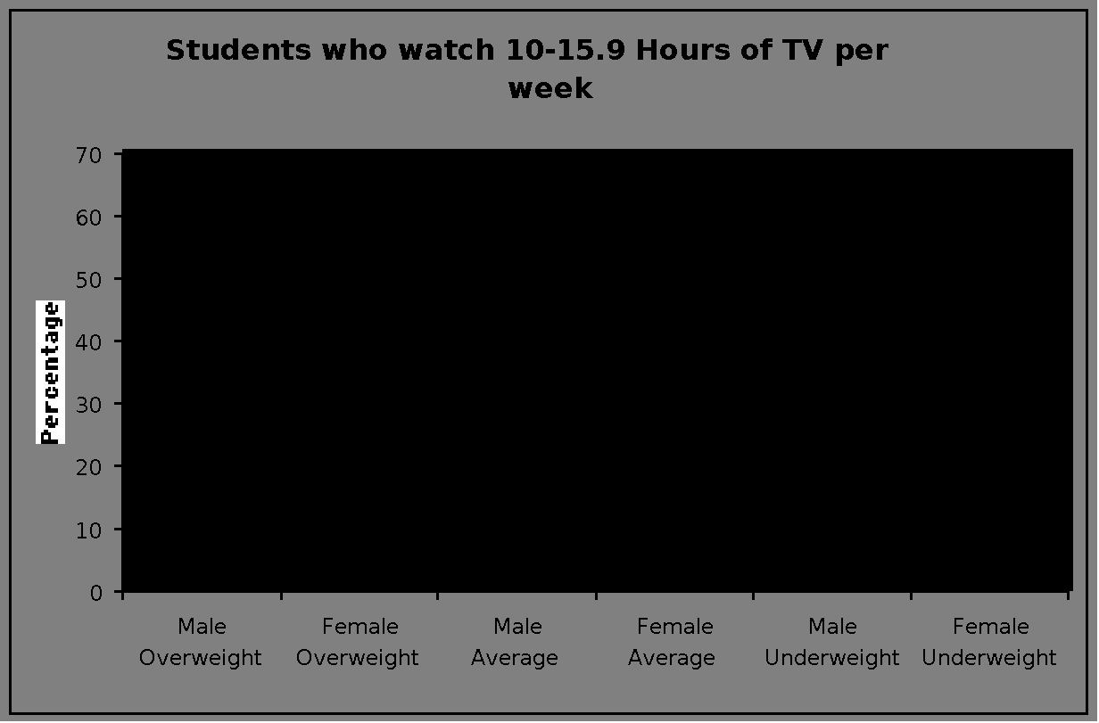

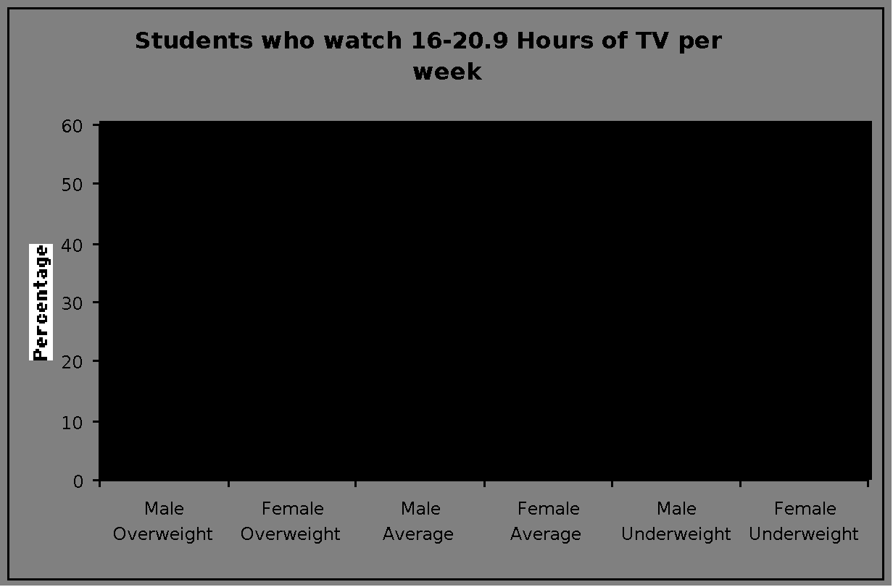

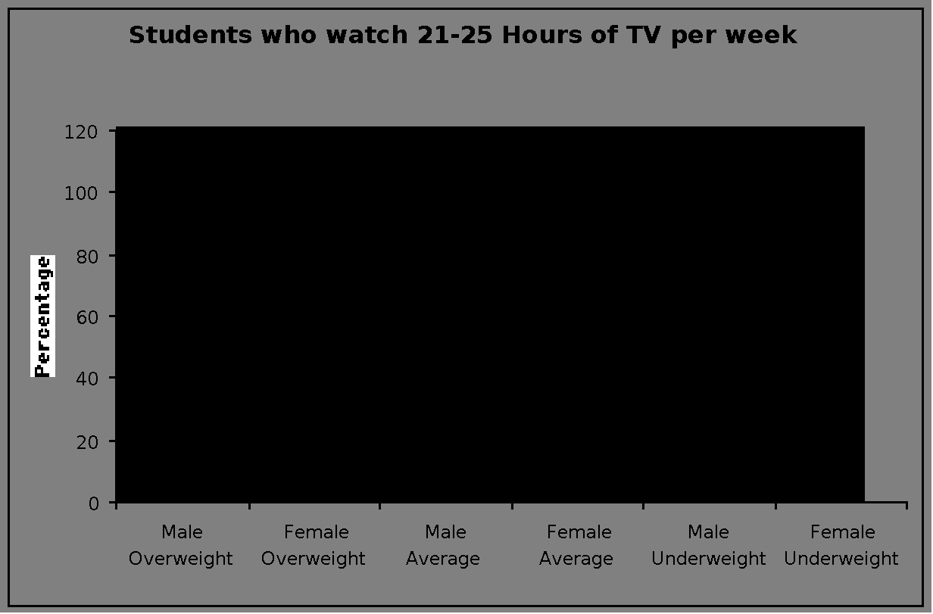

**Conclusion**

The results of the graphs show that for females, their body image is poorer when they watch more then 5.9 hours of television per week. For males, it shows that their body image stays almost the same for any amount of television that they watch. At one point, the amount of females who thought they were overweight reached over 70% of the females. The last graph can not be used as a fair judge of the effect more television has on body image because there were only a few people who watched that much television, therefore, the last graph does not adequately portray the effect television has on body image. The graphs also show that most females find themselves average or overweight while the majority of males find themselves average with some underweight and very few as overweight. It can be concluded that that is a result of the amount of television that influences girls to feel like they need to be thin, and petite, and boys like they should be muscular, brawny and strong.

The data is another interesting piece of data. If you look closely at the heights and weights, one will notice that not one child on the sheet could be considered obese, and very few could be thought of as overweight. Many of the girls and some of the boys who viewed themselves as average weight were actually on the thin side, and would be called underweight by a medical professional.

Overall, from the data collected, my hypothesis was correct. The amount of television a female watches does in fact influence their body image negatively and the amount of television a male watches has little or no affect on their body image. There are some biases and other factors that could have affected the data, but the evidence is still substantial enough to suggest that the amount of television someone is exposed to has the power to alter their body image.

So is television to blame for disordered thinking and possibly eating disorders? It is definitely a factor that needs to be considered thoroughly. Our society is obsessed with the need to be thin, and look like the celebrities they see on television.

Hopefully, this information will not only be read as a biology project, but people will read this and realize the effect that too much television can have on their body image and ultimately self esteem. After realizing the harmful effects of too much TV, teens might fill their time and minds with more positive messages and parents will more closely monitor the amount and content of the television their children are watching. Television can be entertaining, but it also holds an immense power to alter the way we feel about ourselves and out bodies.

**Recommendations**

Before conducting the survey, I tried to predict the biases and alter the procedure so that the survey would be as scientific as possible, but there were still some problems with the survey. For the future, I would recommend:

1) A bigger sample size- this would ensure that people from all walks of life and family types were surveyed. This would also ensure that enough people to make accurate graphs were surveyed.

2) Test students from different schools and possibly cities. This would make sure that people from different environments are included in the survey and that it is not only about the people of Pleasanton.

3) Separate the data into grades as well as male and female and graph the results for each grade. This would show if certain grades were especially susceptible to media influences and if they contributed to swaying the data of all grades one way or the other.

4) Have more choices on the survey such as extremely overweight, extremely underweight etc. This would make sure that the results reflected exactly how people felt about their bodies.

**Bibliography:**

1. Claude-Pierre, Peggy. "The Secret Language of Eating Disorders".

2. Kolodny, Nancy J. "When Food's a Foe".

3. Levenkron, Steven. "Treating and Overcoming Anorexia Nervosa - The Classic Guide".

4. Siegel, Michele. "Surviving and Eating Disorder - Strategies for Family and Friends".

5. Smith, Chelsea. "Diary of an Eating Disorder".

6. http://home.pb.net/~Karynl/facts.htm

7. www.eating-disorders.net